PRE & POST TEMPORARY HOLIDAY SITES
for the
NATIONAL FEAST OF LANTERN 2019

BREAMORE HOUSE,
Near Fordingbridge

Fri 30th Aug - Fri 27th September
Price: £8.50 per unit night
30 Miles from NFOL (MR. 184/154191)

New Forest D.A. welcomes you to Breamore House Holiday Site. Easily accessible from A338, this site is ideally situated for exploring the delights of the New Forest; The Market towns of Ringwood & Salisbury are within easy reach.

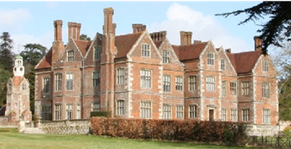

Facilities: The site includes mains water, dry waste and toilet disposal. Own toilets are essential. All types of units are welcome.

Advance booking not required.

Birchwood Tourist Park,
Wareham Forest

Wed 4th September to Wed 2nd October
Price: £12 per unit night includes EHU
30 Miles from NFOL (MR. 195/893913)

New Forest D.A. welcomes you to this Holiday Site in delightful Dorset on the edge of the Purbecks and in Wareham Forest, centrally located in an ideal position for exploring Dorset and the Jurassic Coast.

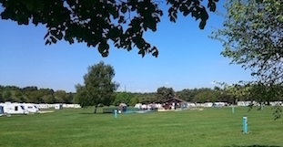

Facilities: The site includes mains water, dry waste and toilet disposal. There are 2 toilet/shower blocks which we have full use of. All types of units are welcome.

Advanced booking is essential, Email jsetchell20@talktalk.net or text 07513409978 leave name & contact telephone for us to contact you.

Beehive Field, Bradford Upon Avon
Fri 13th to Mon 30th September
Price: £8.50 per unit night
28 Miles from NFOL (M.R. 173/834598)

Somerset DA welcomes you to this large flat field green field holiday site. It is equidistant between Bradford-on-Avon and Trowbridge, and enjoys a peaceful rural location. Plenty of activity at Widbrook Marina provides a source of entertainment for all the family, and has an onsite public house, The Beef & Barge. The local public transport is available from just outside the gate, allowing easy access to the majority of main bus routes.

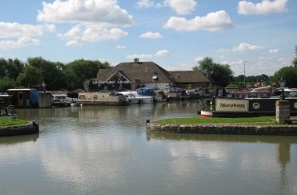

Facilities: Greenfield site, own sanitation essential
Advance booking not required.

